Wenzhou Safewire Electric CO.,Ltd.
SPECIFICATION SHEET

PRODUCT NAME: Desktop socket
PRODUCT No.: FZ-TB-B

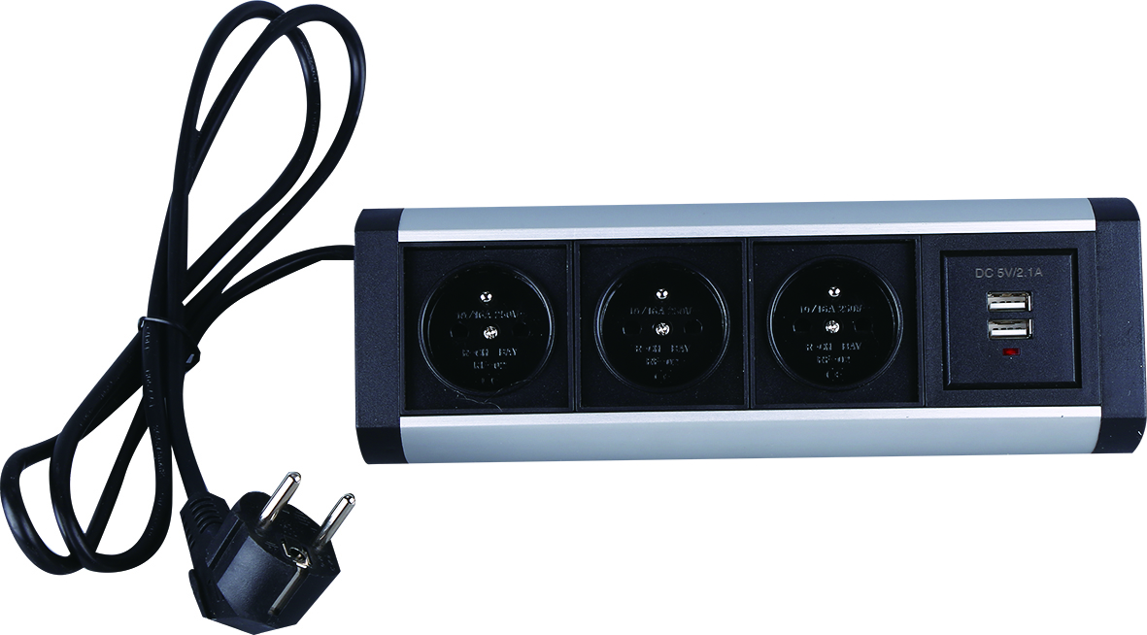

Address:2nd floor, Wealth Garden, Liushi town, Yueqing, Wenzhou,China ,325604
Tel:0086-577-61725369
Mob:0086-18612380398
ZIP:325604
（E-mail）：info@safewirele.com
(WEB): http://www.safewirele.com

Model: FZ-TB-B
Brand Name : Safewire or OEM brand
Place of origin : Zhejiang ,Wenzhou,China
Rated Current :16A
Type: desktop socket Current Type: AC
HS Code：8536690000 Frequency:50Hz~60Hz
Grounding：Standard grounding Voltage:250V
Color :Black/Silver Market standard: Customized

Serial No. | Parameter | Description
1 | Panel Material | Aluminum alloy/PC
2 | Surface finish | Painted/Brushed Oxygenated
3 | Capacity of modules /Interface size | 50*50mm black modules/45*45mm white modules
4 | Cable length | 1.5m, 2m,3m or required length
5 | Available modules | 6/8/10 ways modules
6 | Plug and cable wire | GST 3 pole socket or power plug cable

Package:
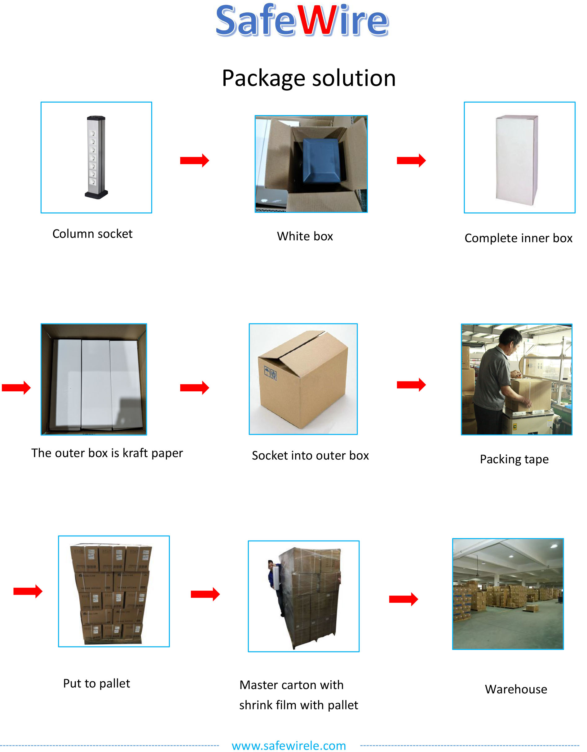

Application:
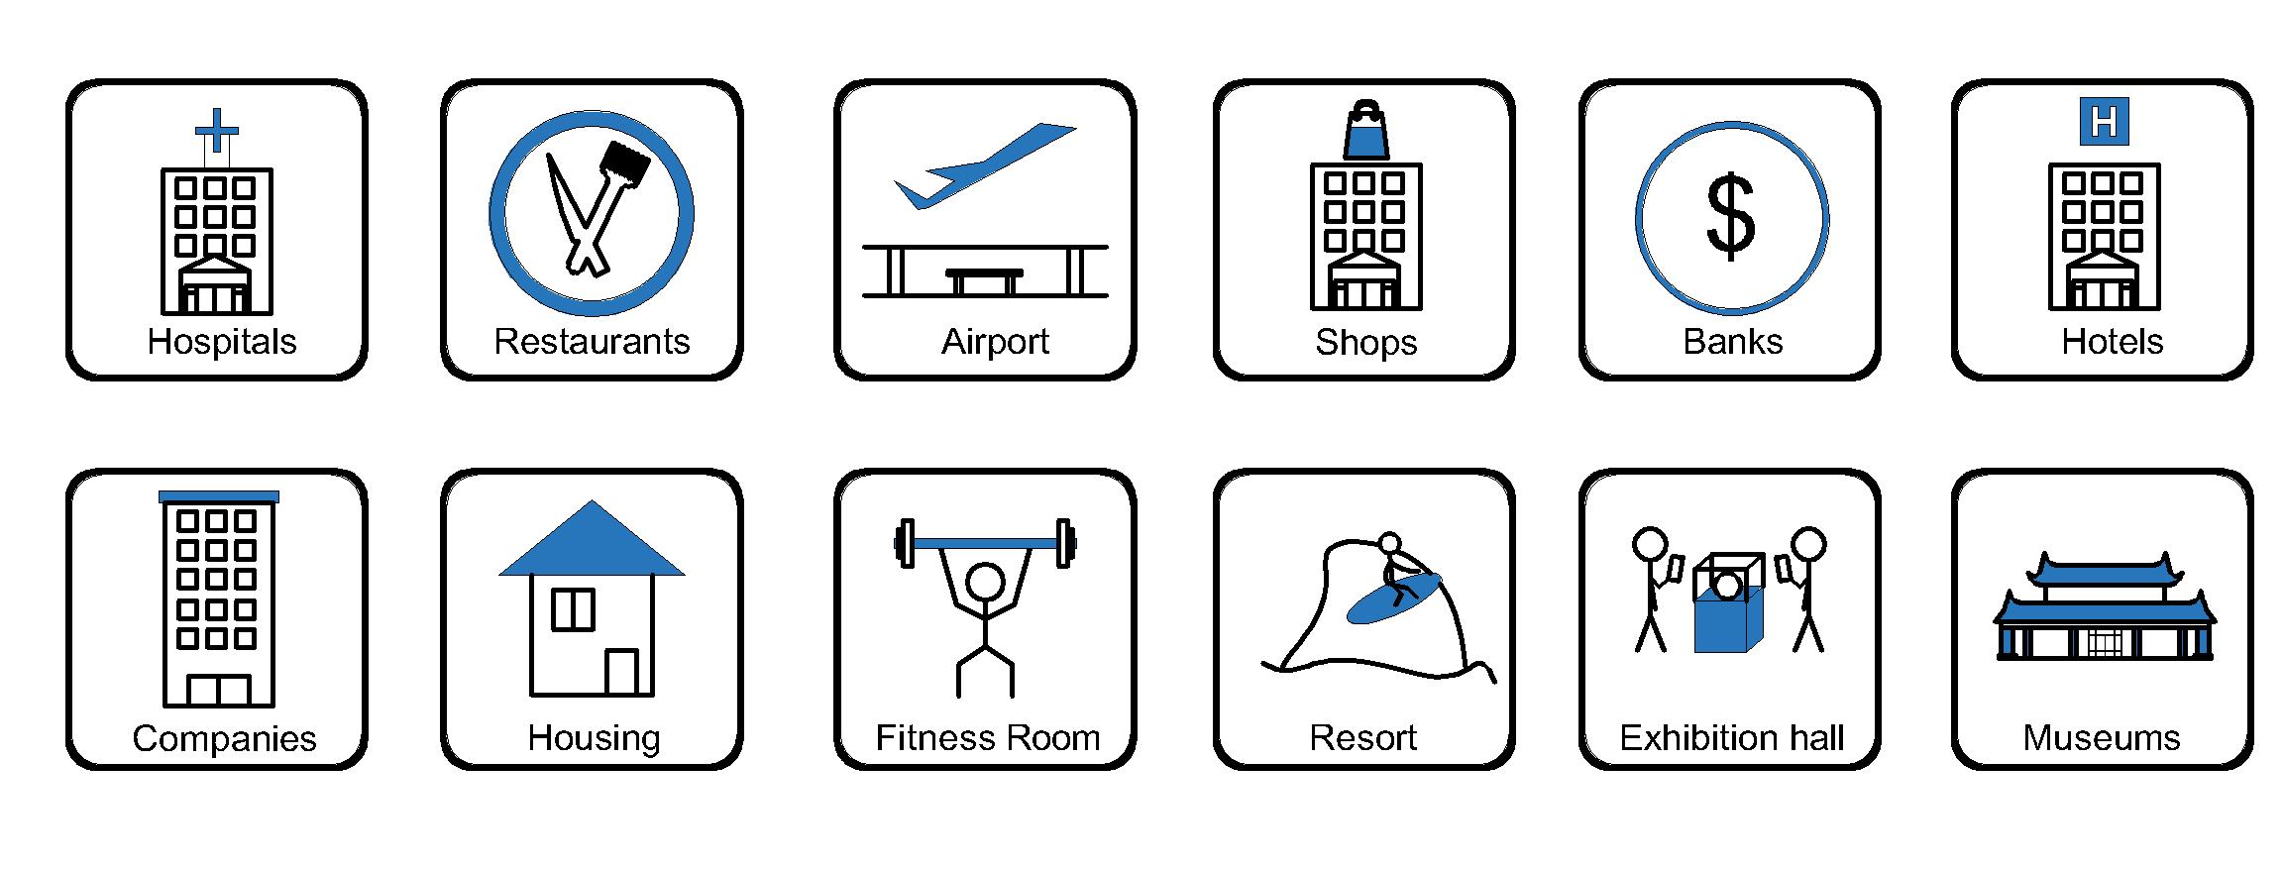
- Office and education
- Industry and Engineering
- Presentation and retail;
- Orientation and safety;
- Transit areas and parking;
- Hotels, hospitality and wellness;
- Health, sport and leisure;
- Art and culture;
Features:
- Double function switch combine indicator and control;
- Wall mounting facility is optional;
3).Support wide range of power and data accessories available to meet all requirements;
4).The length of product & cord cable are customized by requirement.
Product Show:

FZ-TB-B Outline drawing:
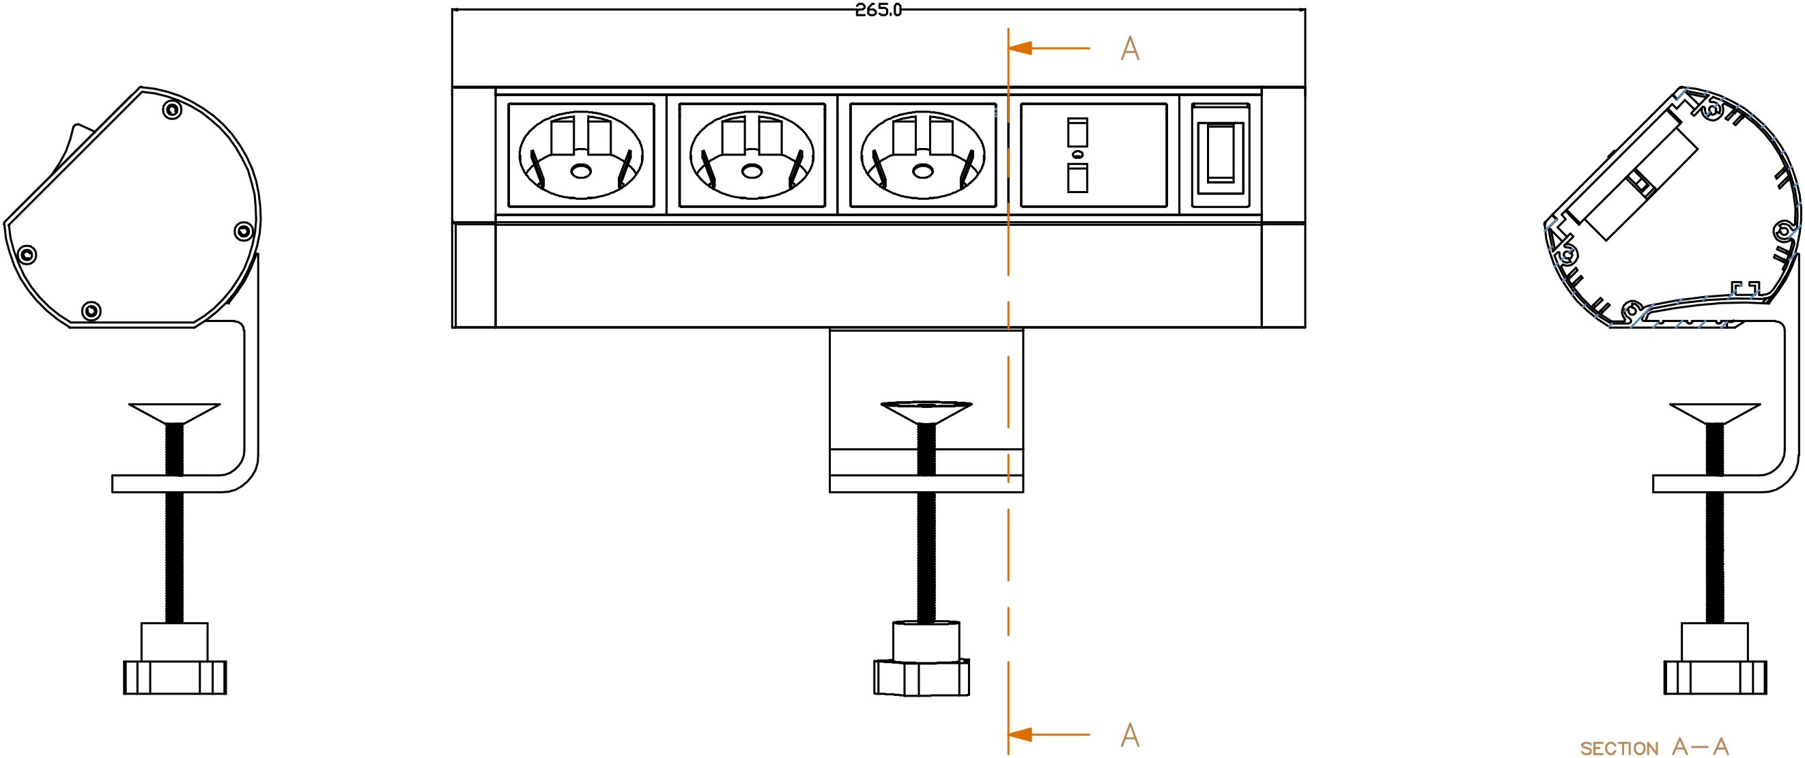

Available sockets or modules types:
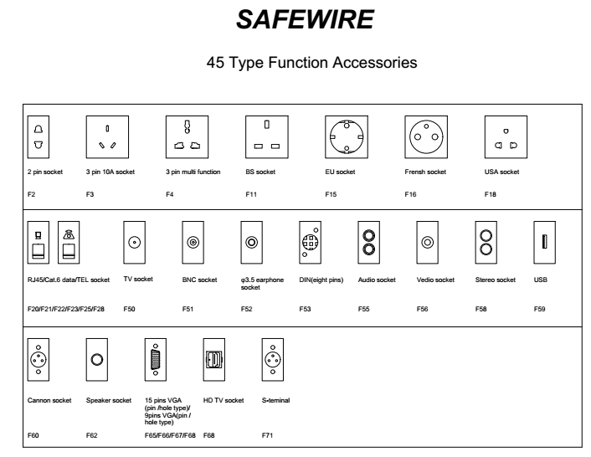

Other specification should be subject to confirmation from Safewire

