Wenzhou Safewire Electric CO.,Ltd.
SPECIFICATION SHEET
PRODUCT NAME: Desktop socket
PRODUCT No.: FZ-PFB02

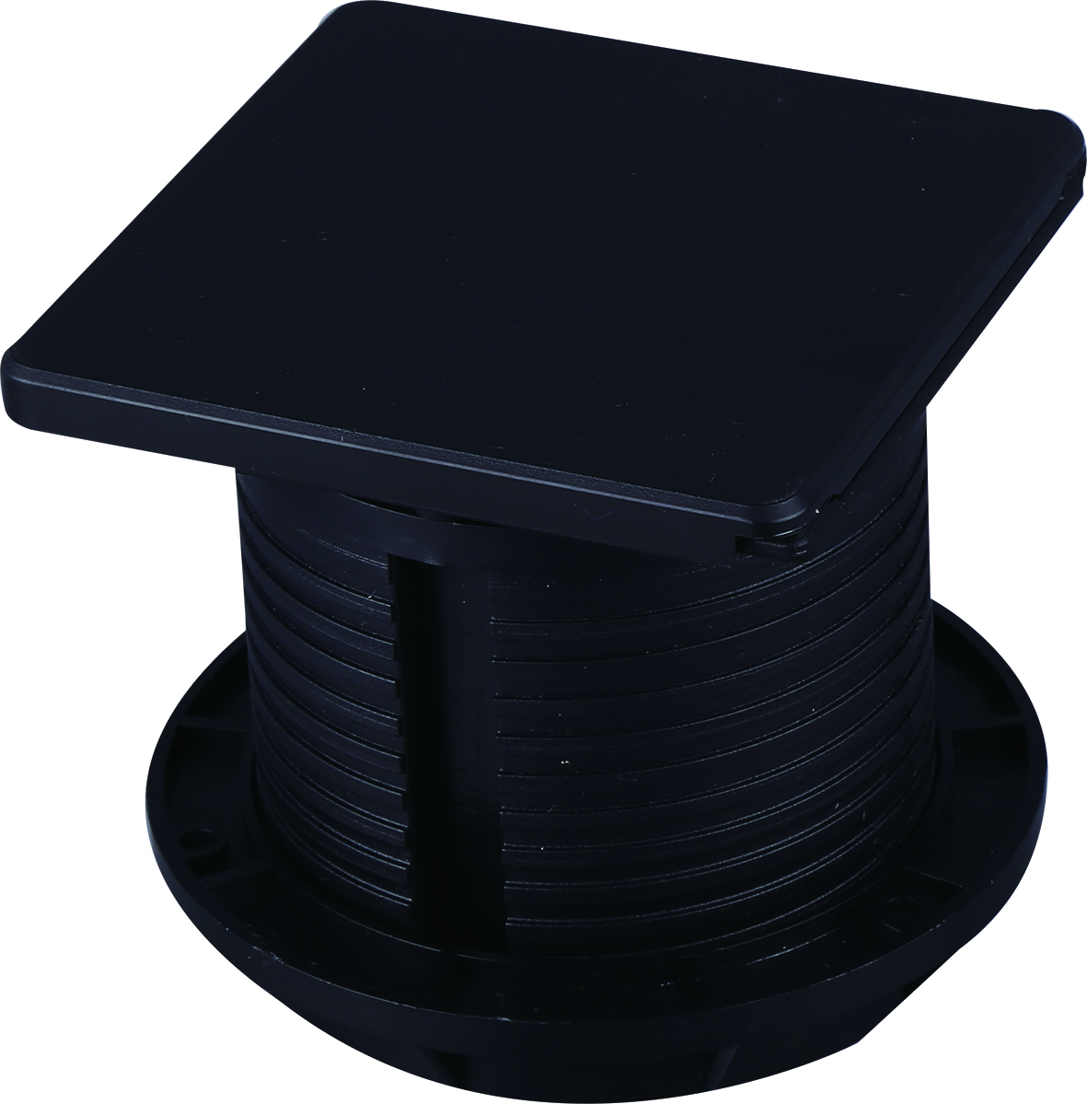

Address:2nd floor, Wealth Garden, Liushi town, Yueqing, Wenzhou,China ,325604
Tel:0086-577-61725369
Mob:0086-18612380398
ZIP:325604
（E-mail）：info@safewirele.com
(WEB): http://www.safewirele.com

Model: FZ-PFB02
Brand Name : Safewire or OEM brand
Place of origin : Zhejiang ,Wenzhou,China
Rated Current :10-25A
Type: Grommets Current Type: AC
HS Code：8536690000 Frequency:50Hz~60Hz
Grounding：Standard grounding Voltage:90~260V
Color :Black or sliver Market standard: Customized

Serial No. | Parameter | Description
1 | Panel Material | PC
2 | Bottom box Material | Enginning PC
4 | Panel Dimension(mm) | 95*94
5 | Cutout(mm) | Ø80
6 | Capacity of modules / Interface size | With two power outlet+dual port USB charger 2.1A
7 | Cable length | 1,2 Mts cable 100% cooper with plug is optional

Package:
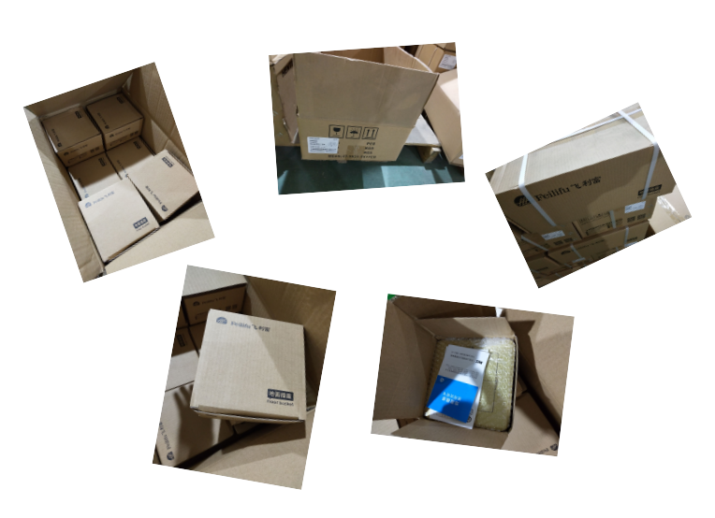
Application:
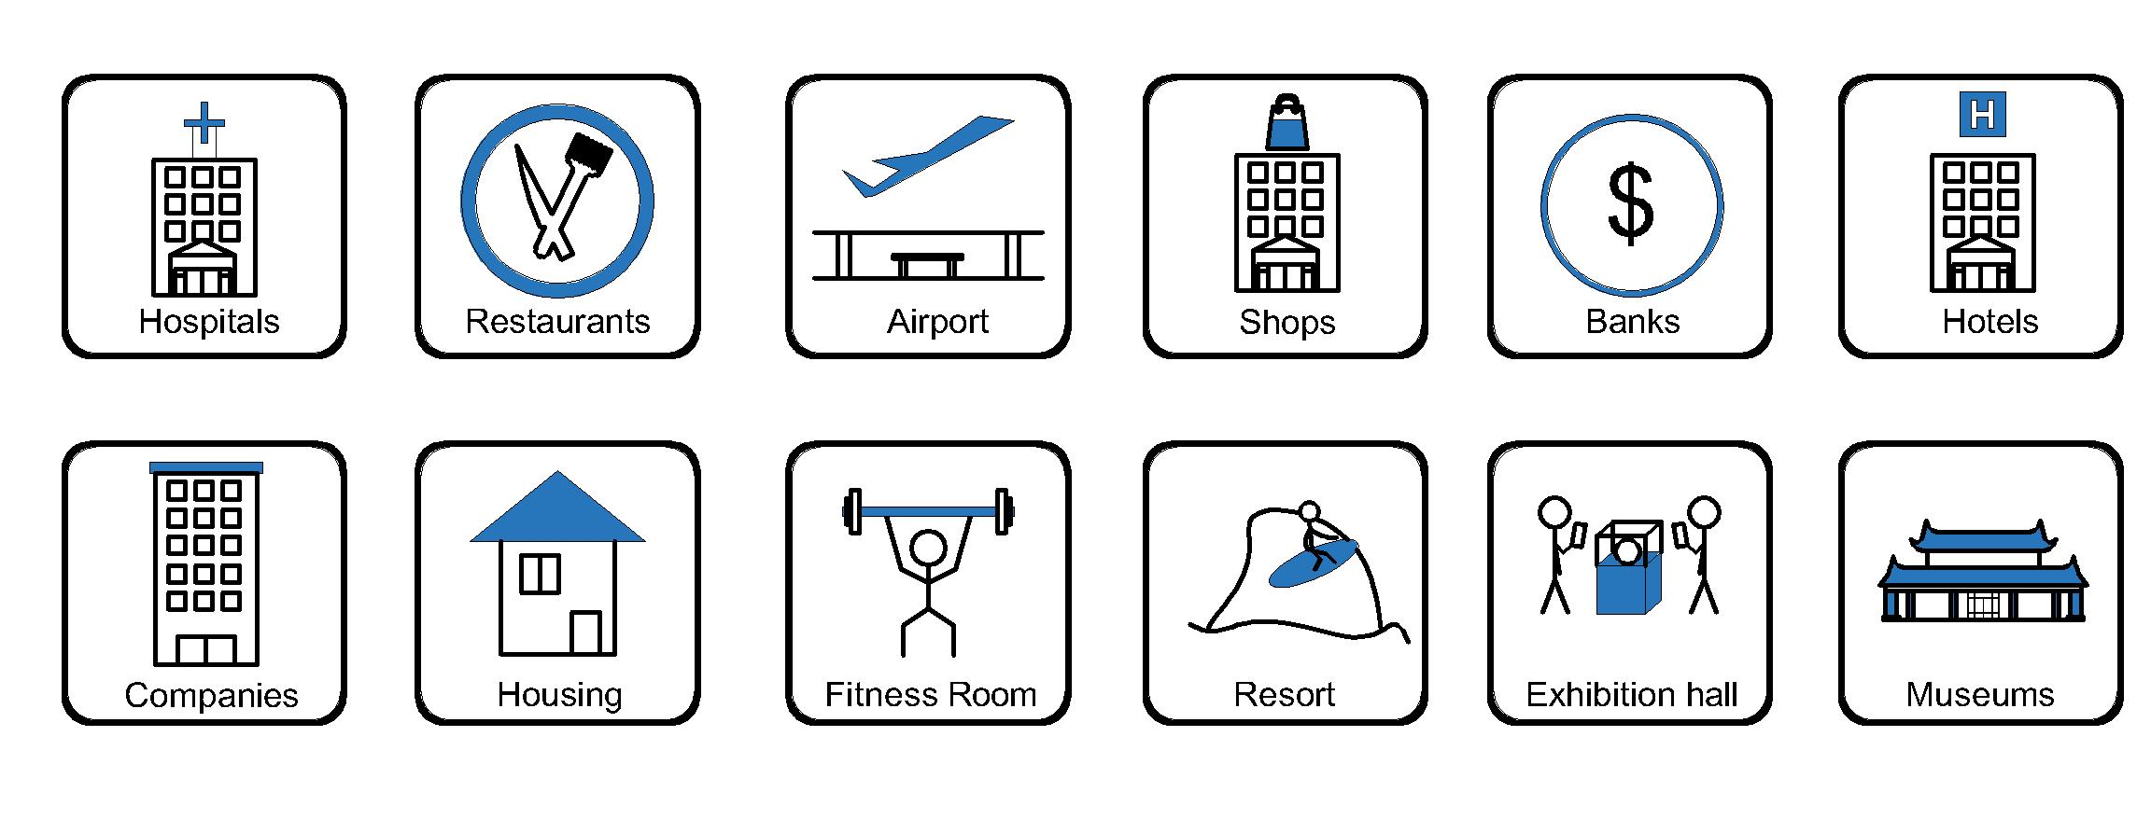
- Office and education
- Industry and Engineering
- Presentation and retail;
- Orientation and safety;
- Transit areas and parking;
- Hotels, hospitality and wellness;
- Health, sport and leisure;
- Art and culture;

Features:
1)Application: Embedded in Sofa or table furniture;
2). IP44 protection level;
3). Slide coverplate surface finish by Power painting;
4) With two power outlet+dual port USB charger

Product Show:
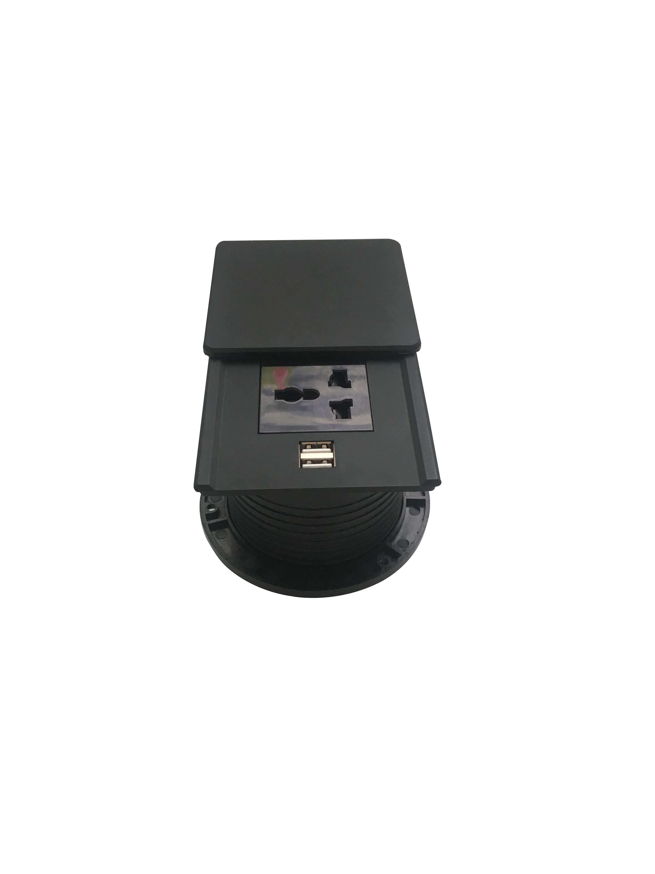

FZ-501 Outline drawing:
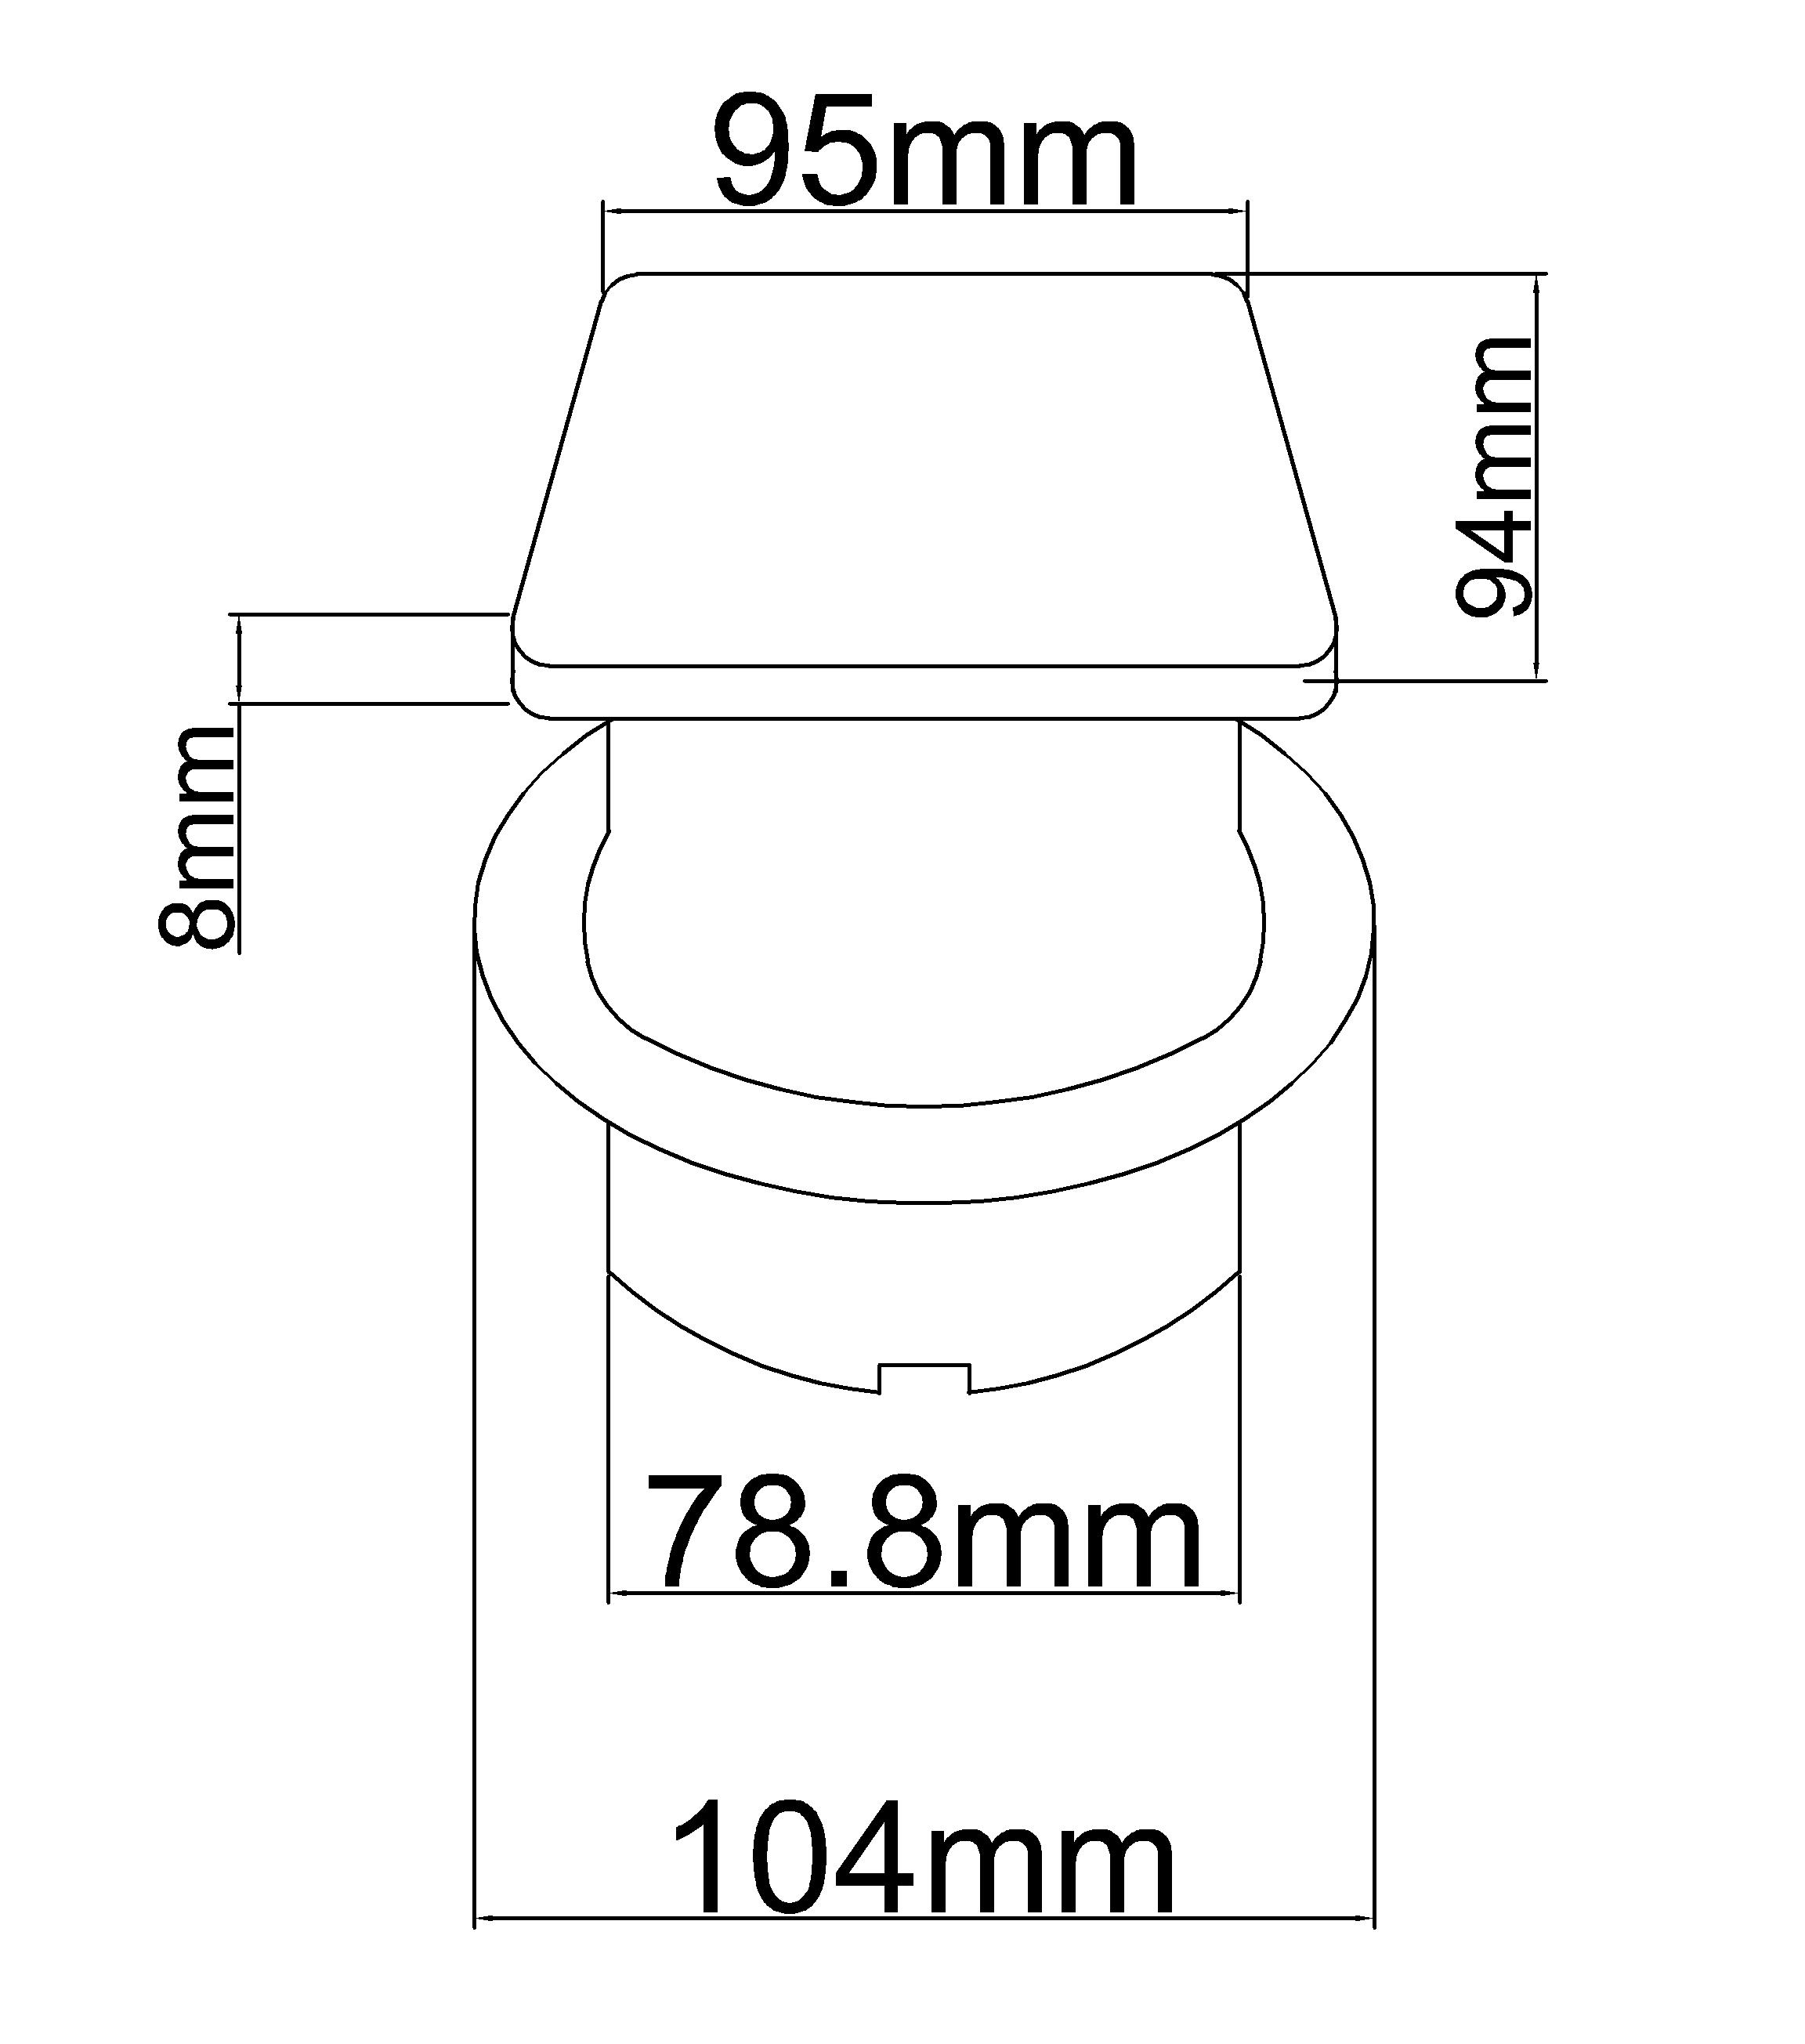

Available sockets or modules types:
