Wenzhou Safewire Electric CO.,Ltd.
SPECIFICATION SHEET

PRODUCT NAME: Automatically pop up powerbar
PRODUCT No.: FZ-527B

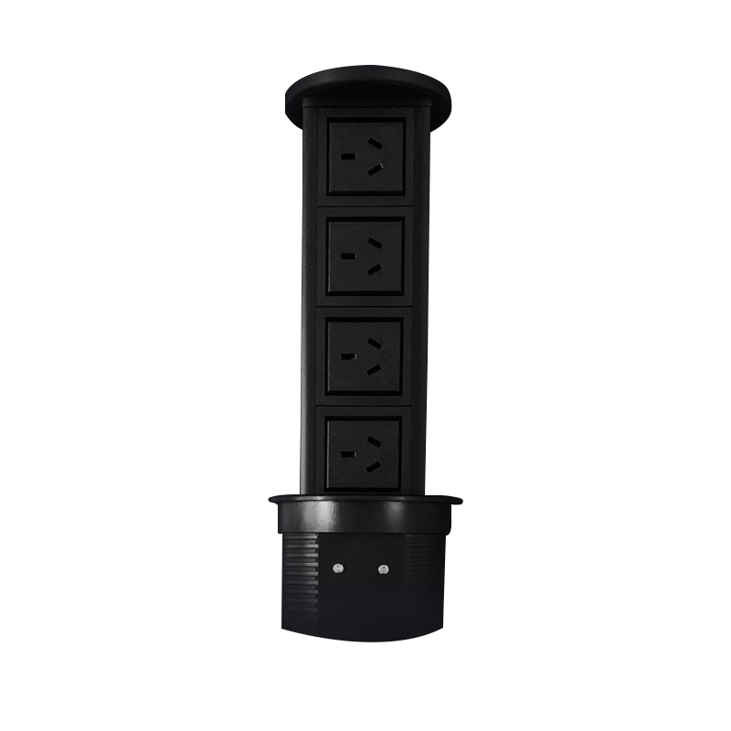

Address:2nd floor, Wealth Garden, Liushi town, Yueqing, Wenzhou,China ,325604
Tel:0086-577-61725369
Mob:0086-18612380398
ZIP:325604
（E-mail）：info@safewirele.com
(WEB): http://www.safewirele.com
Environmental requirements
Serial No. | Parameter | Description
1 | Operating temperature | -10℃~+40℃;Operating
2 | humidity | 20%~90% RH
3 | Storage temperature | -20℃~+85℃;storage
4 | humidity | 10%~95% RH
5 | Resistance to pressure | ≥3Kv/AC 1min
6 | Isolation resistance | 500v DC/100MΩ

Technical parameters :
Serial No. | Parameter | Description
1 | Material | Aluminum 6063, PC zinc alloy
2 | Optional color | black
3 | Panel Dimension(mm) | Ø120
4 | Cutout(mm) | Ø100
5 | Height when closed(mm) | 435
6 | Height when pop up(mm) | 667
7 | Capacity of modules /Interface size | 8 ways 45*45mm Legrand’s Mosaic modules
8 | Configuration | Power outlet+Data outlet or USB charging : Customized as required
9 | Cable length | 1.5m or required length
10 | Time of engine motor | MAX 1000h

Application：
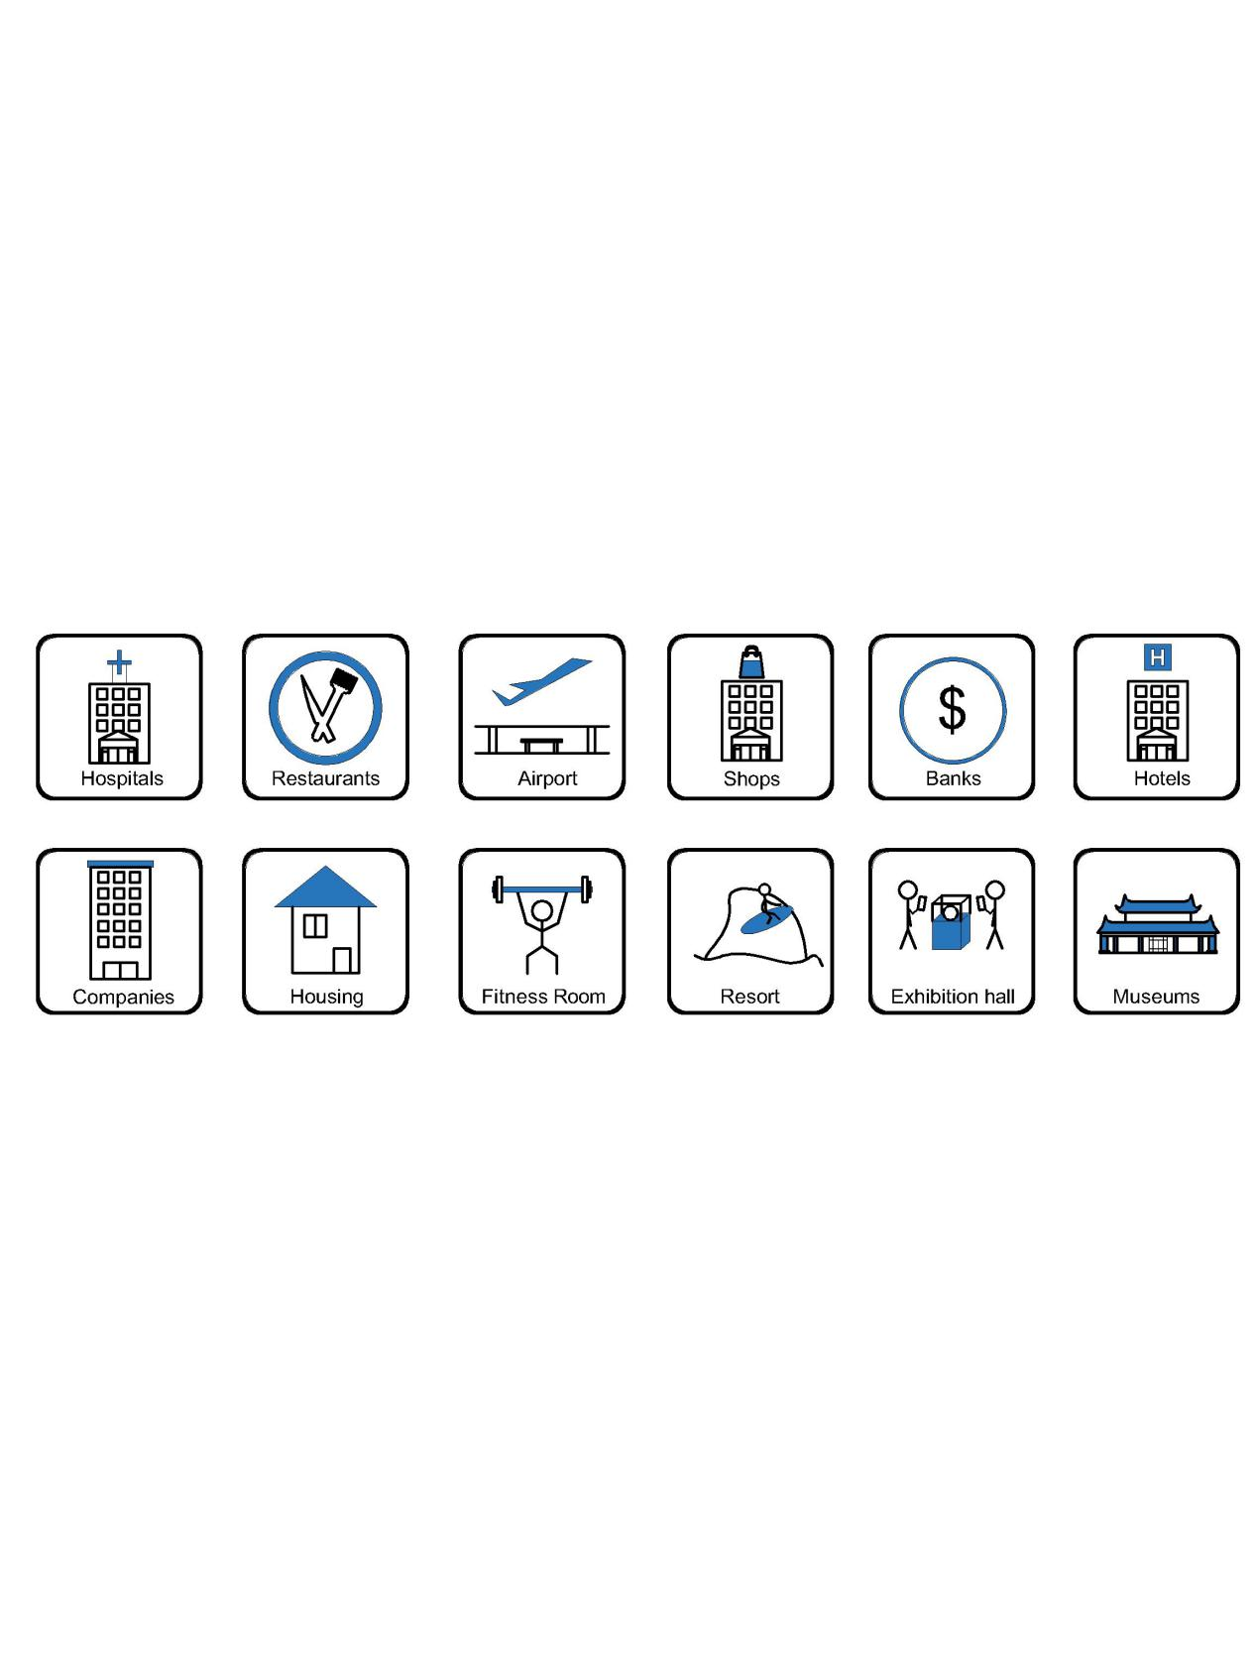

- Office and education
- Industry and Engineering
- Presentation and retail;
- Orientation and safety;
- Transit areas and parking;
- Hotels, hospitality and wellness;
- Health, sport and leisure;
- Art and culture;
Product Show:
Features:

- Automatically on/off,Optional wireless charger of QI
- 2.1A/4.2A fast USB charger and blue tooth speaker outlet etc
- International 45mm Legrand’S modules/outlets
- Aluminum alloy 6063 reliable light housing
- optional 1.5 M International IEC plug and cora of 1.0 mm²square or 1.5mm² square.
- LED control panel design.

FZ-527B Outline drawing:

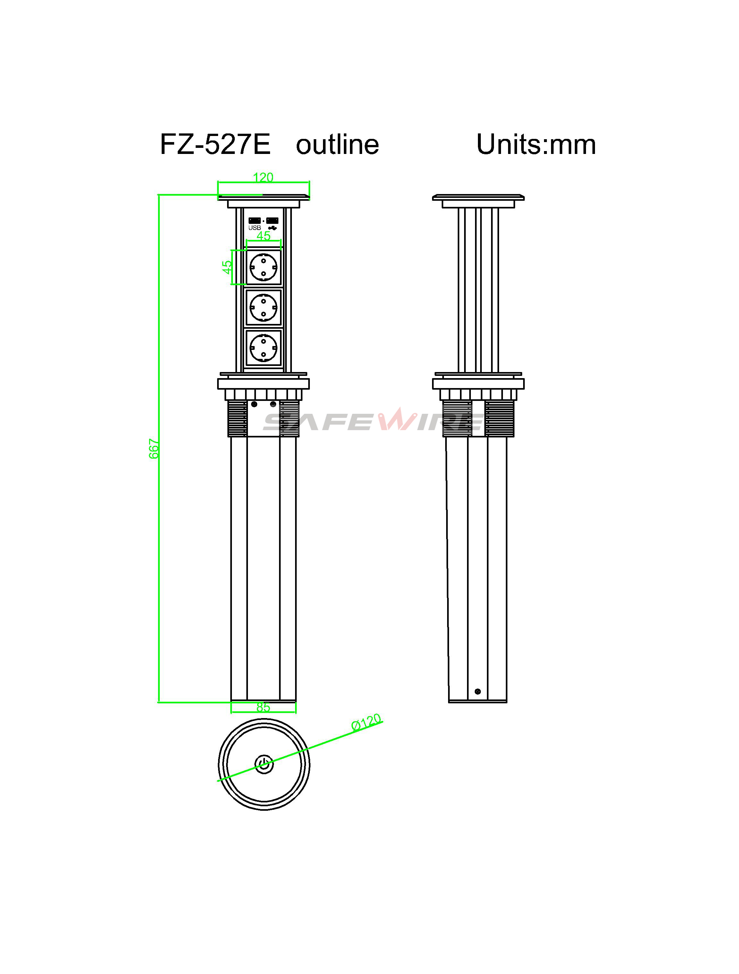

Package:4 Pcs inner box into a master carton.Poly bag with box packing
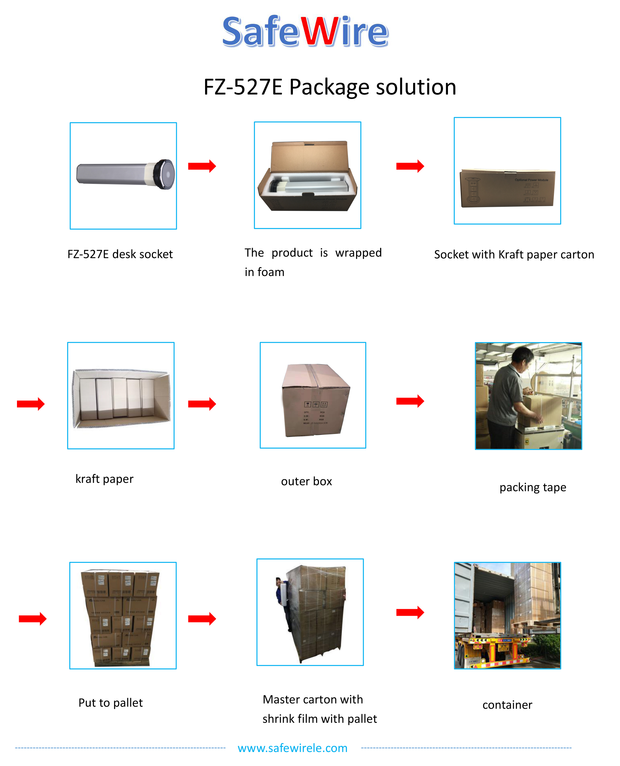
.
Mounting ring thread

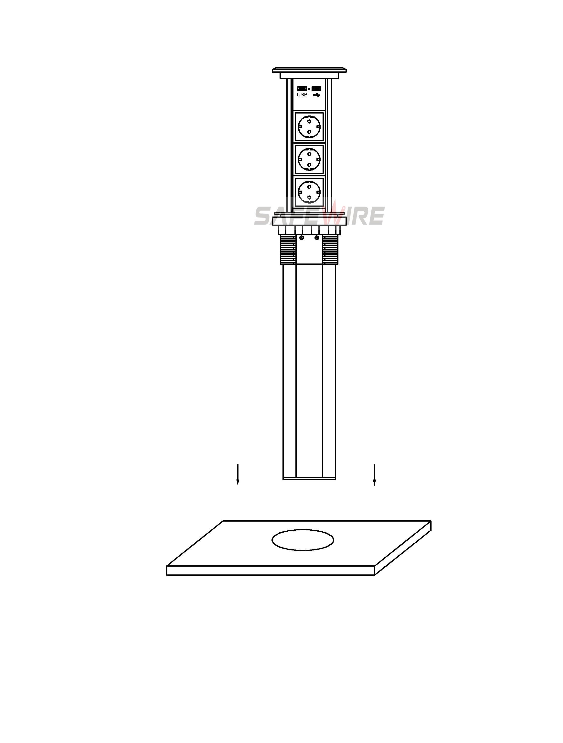
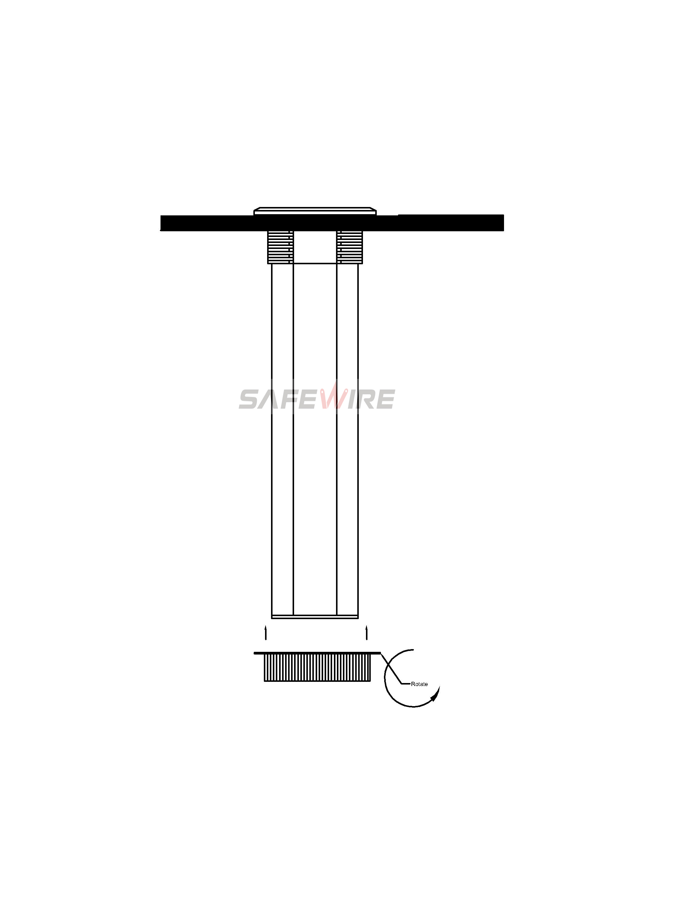

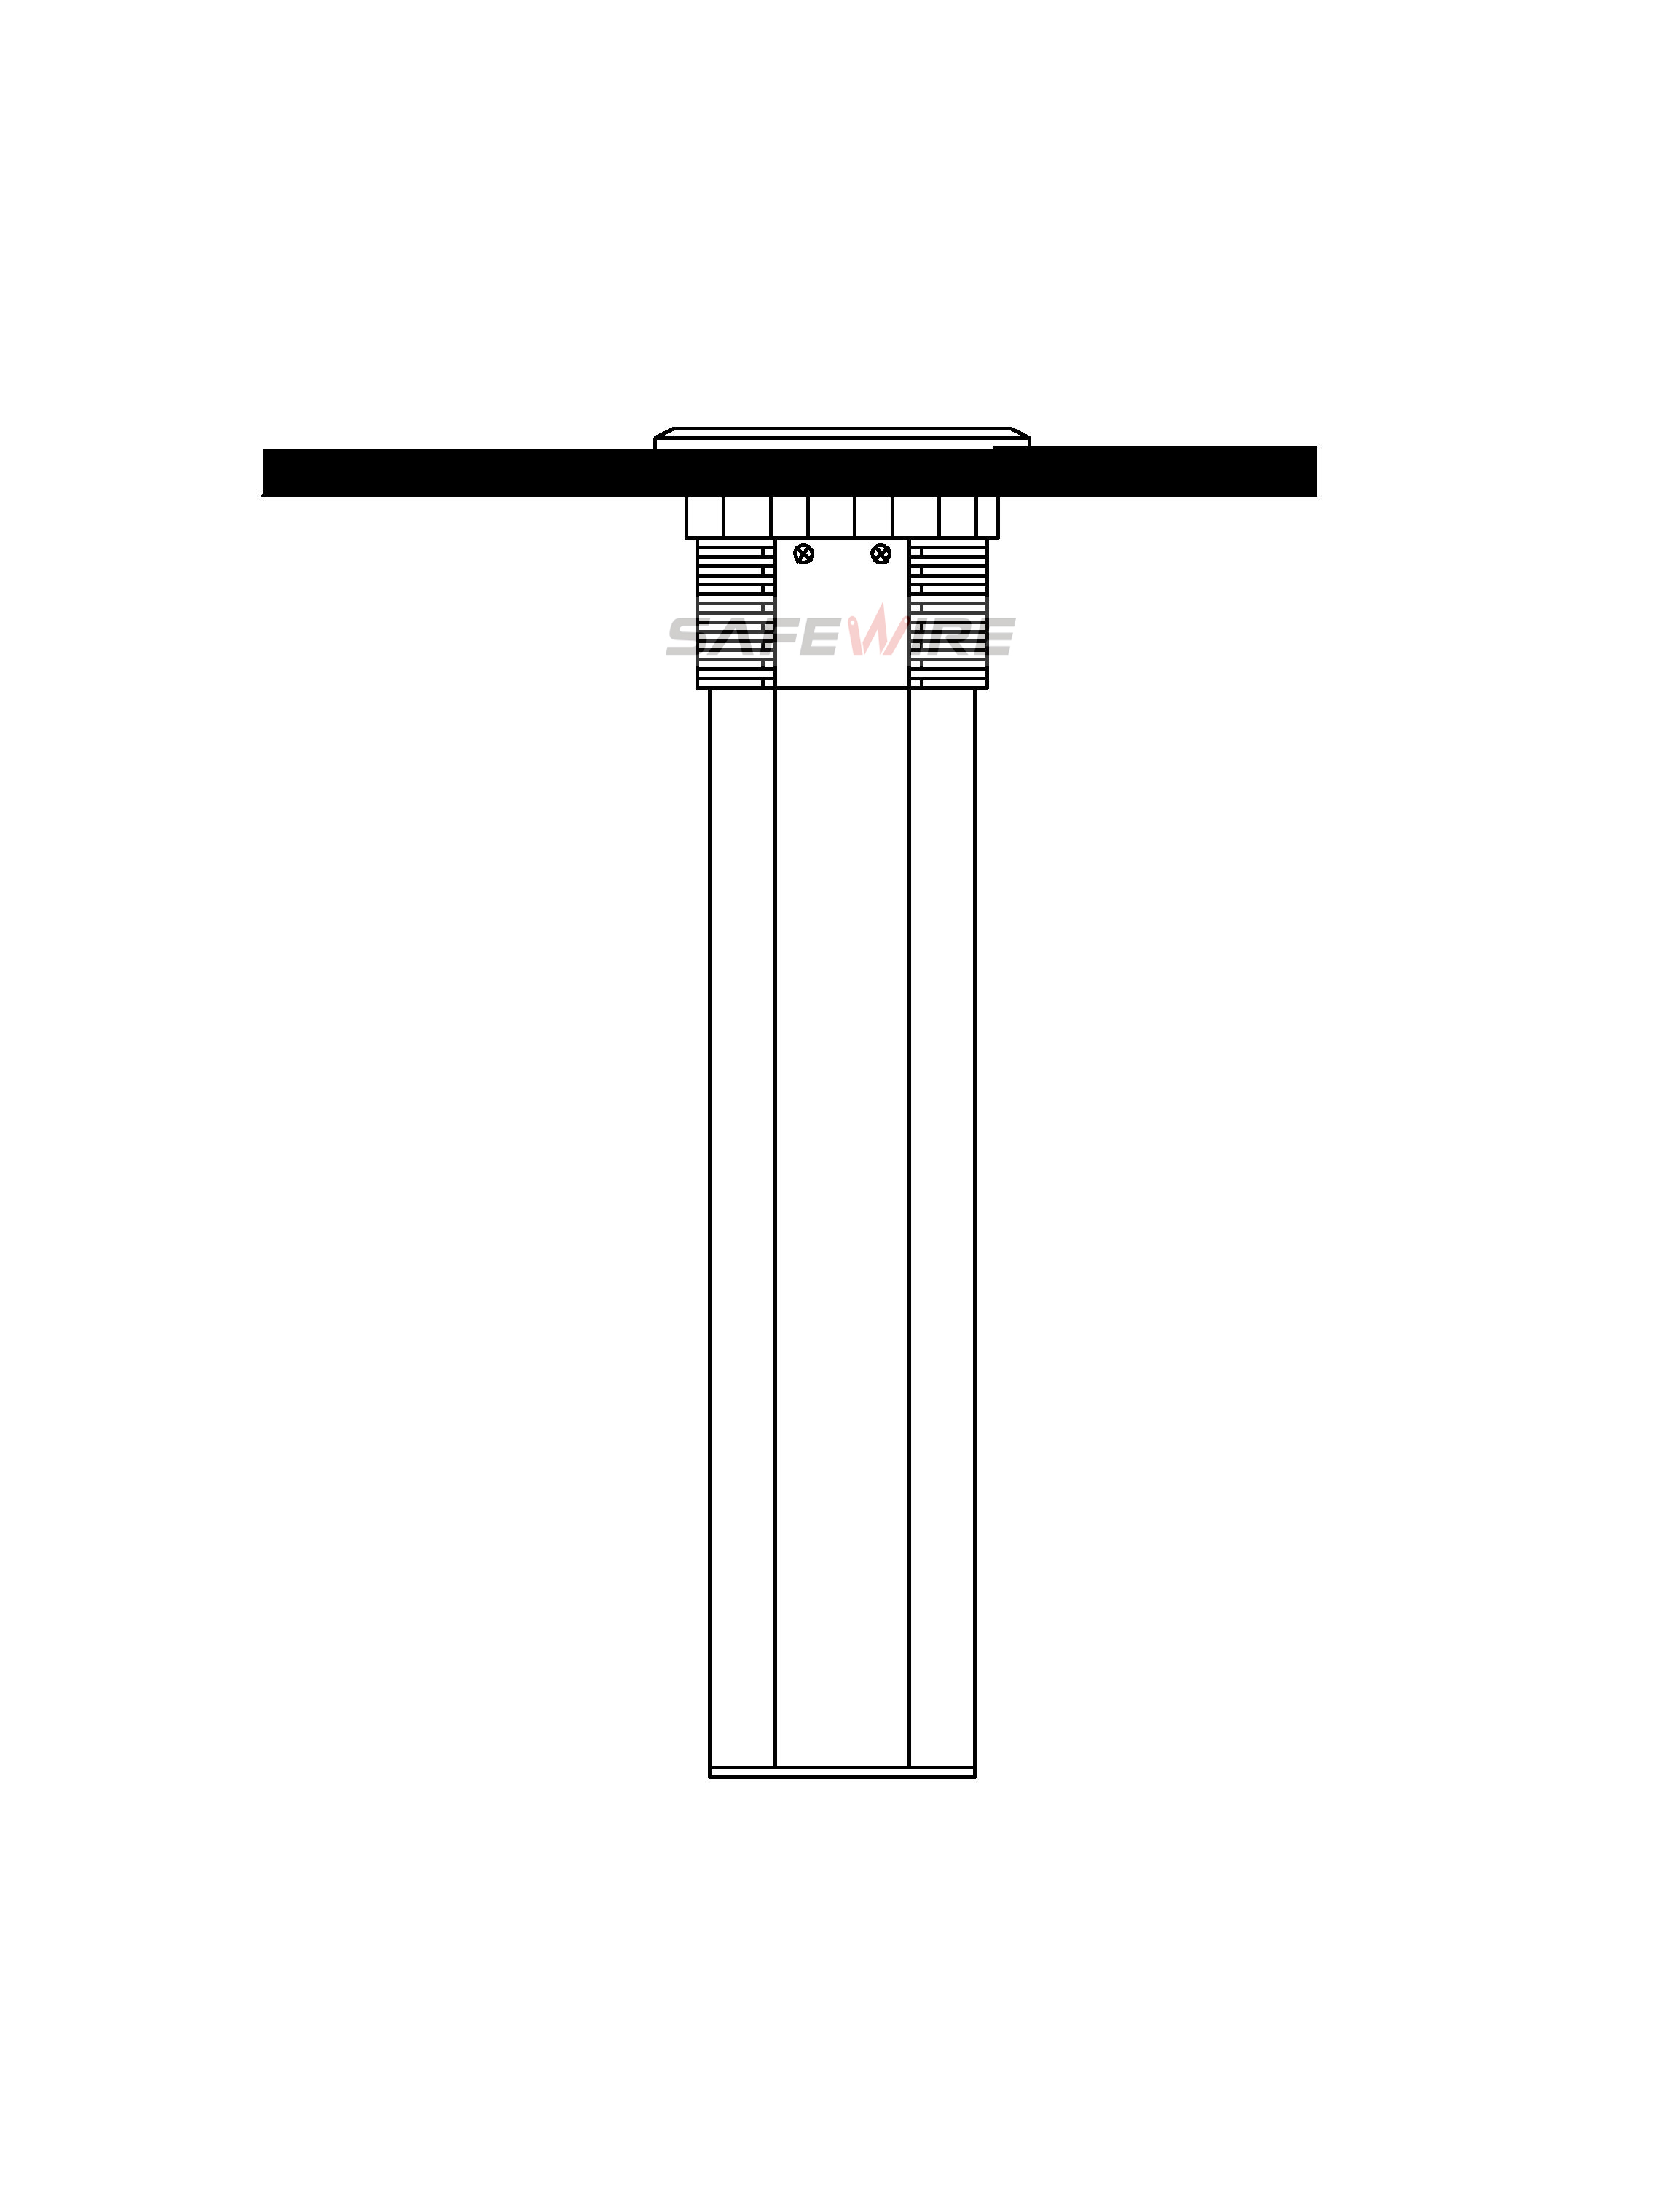
（1）
（2）

（3）

Installation Process
- Open a circular hole with a diameter of 100mm.
- After removing the buckle，insert the product into the hole in the tabletop.adjust the direction and fix the product on the buckle at the bottom of the tabletop.
- Connection cable and tighten the screw ring to use

Available for F type 45*45mm type or D type22.5*45mm international sockets or modules types:
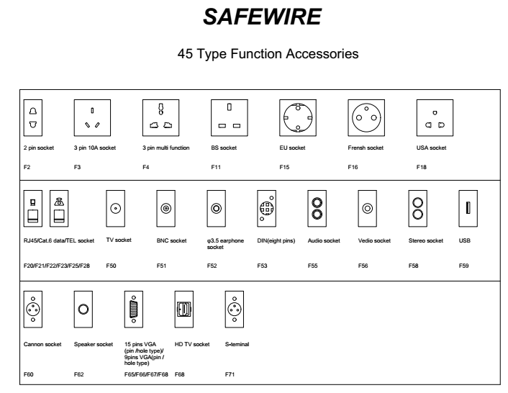

Attentions:
1.Prevent from corrosive liquid, gas (strong acid, strong alkali, paint)and humidity.
2. All dimension quoted are nominal only. Drawings , images and text are for illustrative perposes only and product details and dimension are subject to change without notice.

Safety Warning:
- For the protection and safety of you and others,please read this manual before installation.If you have something you don't understand when you install it,please contact us in any time.
- Please noted that the sum of current (power) should not exceed the rated current (power) of the product.3*1.0 square power cable with a maximum power of 2000W,3*1.5 square power line maximum power 3000W
- Please install this product in a location that is out of reach of children to ensure personal safety.
- To avoid electric shock, fire, and electrical failure ,please don't install this product in a humid environment.
- To avoid electric shock and fire,please don't damage the power cord and power outlet.
- To avoid electric shock and the expiration of the warranty period,please don't disassemble this product.
- To avoid electric shock and fire caused by electrical leakage,connect a cable with a grounding.

