Wenzhou Safewire Electric CO.,Ltd.
SPECIFICATION SHEET
PRODUCT NAME: Floor box
PRODUCT No. : HTD-6130
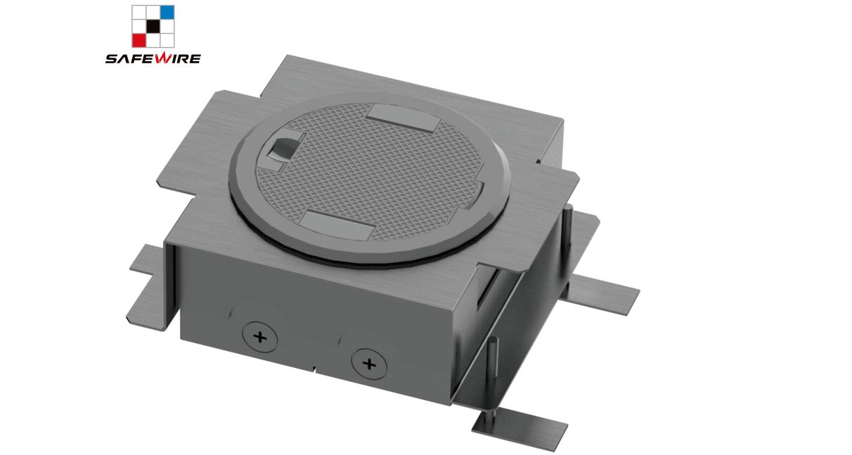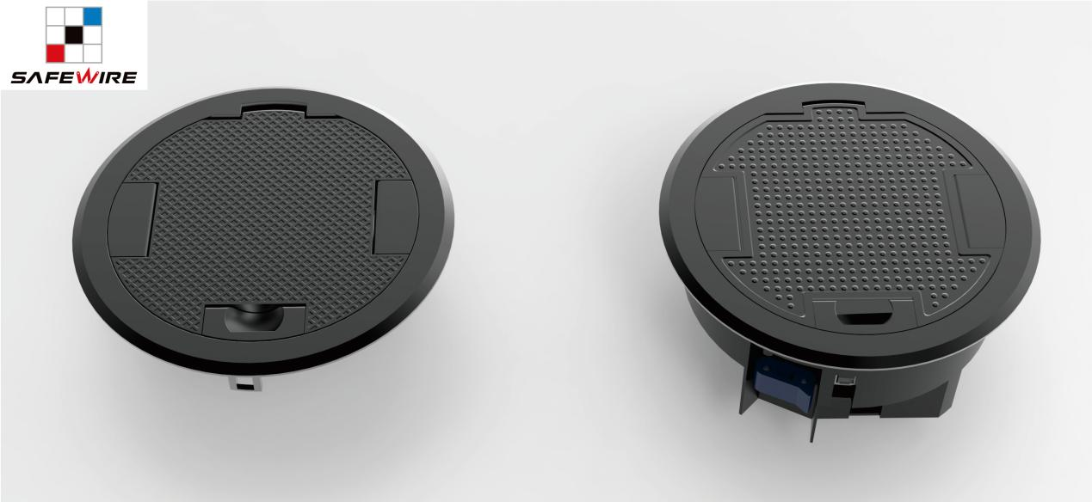
Address:2nd floor, Wealth Garden, Liushi town, Yueqing, Wenzhou , China, 325604
Tel:0086-577-61725369
ZIP:325604
Mob:0086-18612380398
(E-mail): happyhe@safewirele.com
(WEB): http://www.safewirele.com
Technical parameters & characteristic :
Serial No. | Parameter | Description
1 | Shape column | circle
2 | Panel Material | Zinc alloy
3 | Surface finish | Painted/Brushed Oxygenated
4 | Height of product(mm) | 90(adjustable)
5 | dimension (mm) | Φ=195
6 | Capacity of modules | 45*45/45*22.5(mm) modules
7 | Configuration | Power outlet+Data outlet or USB charging+HDMI+VGA+Audio socket(Customized as required)
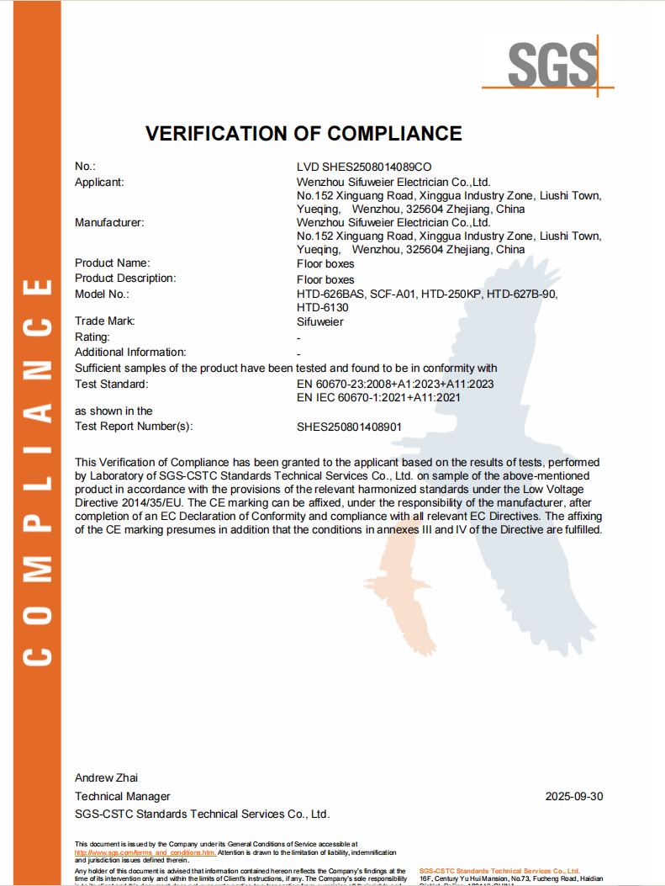
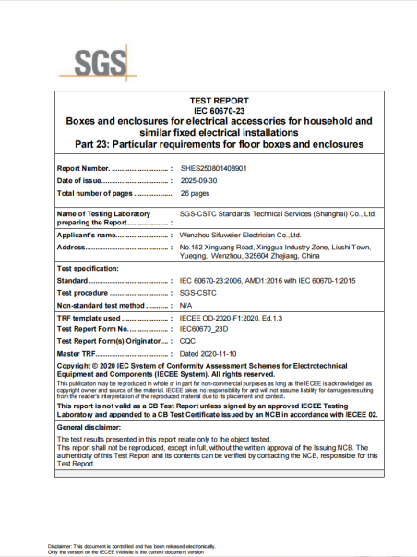
Component Description :
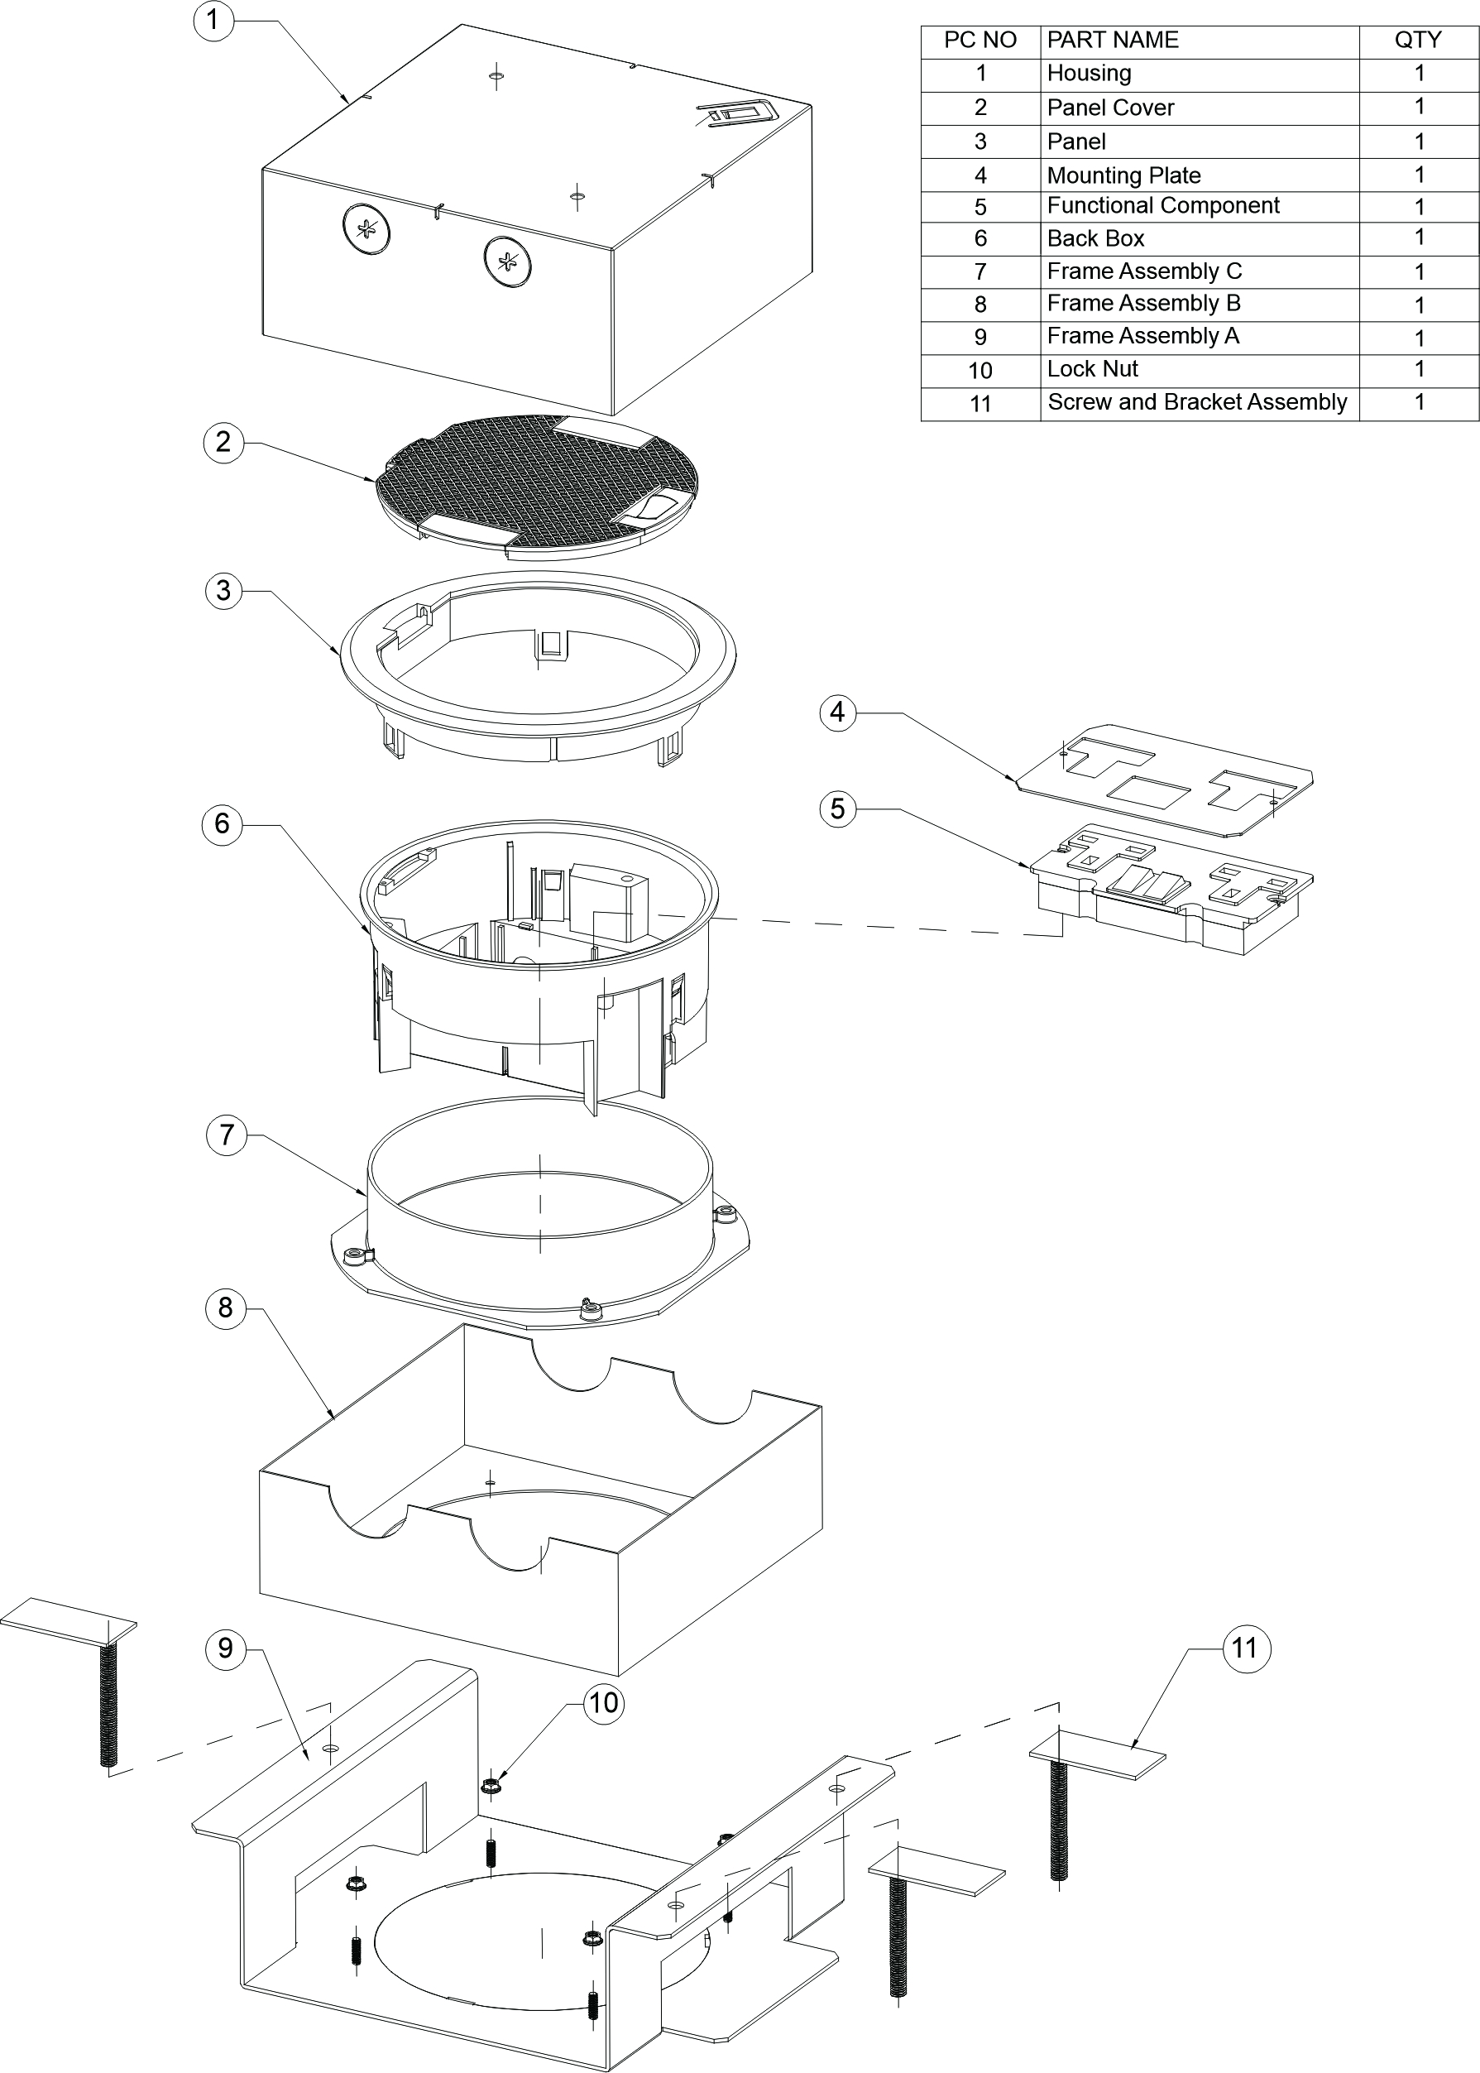

Product drawing:
1）Floor box:
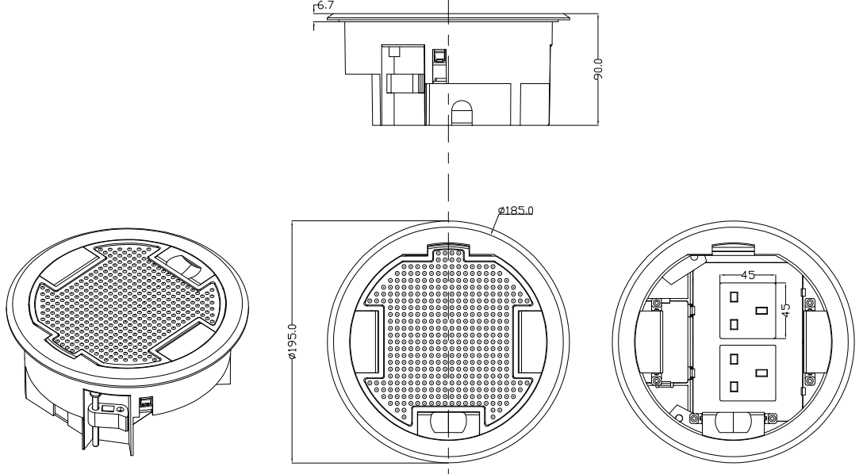
2）Height-adjustable outer frame base:
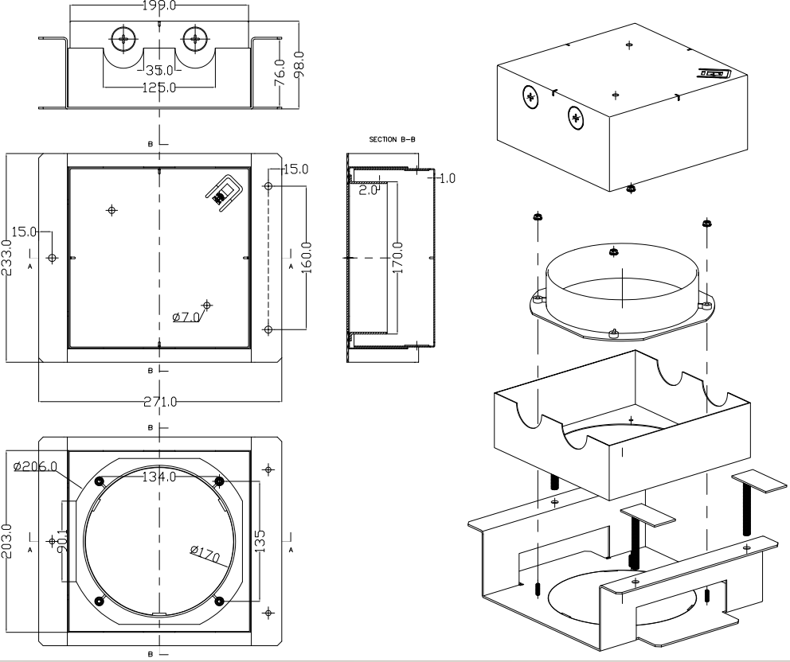
Product functional components drawing :
1) 45 Type Funtion Accesoies
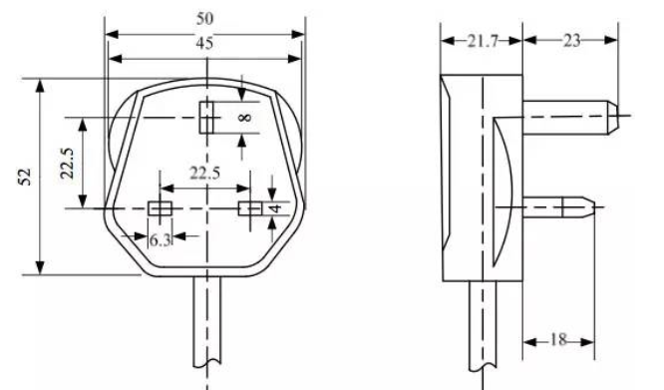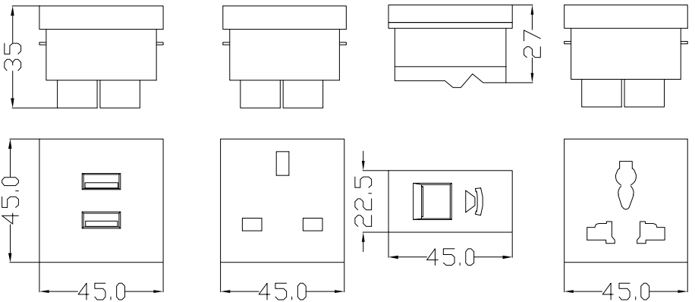
2) 50 Type Funtion Accesoies
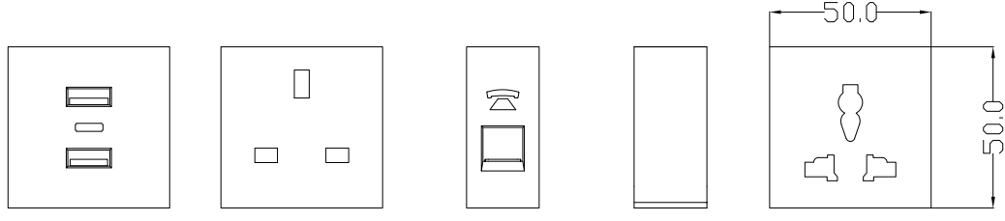
3) 86 Type Funtion Accesoies
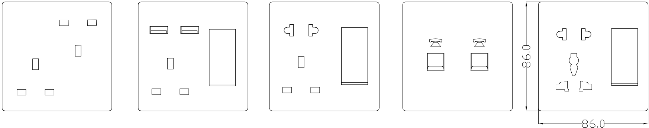
4) 110 Type Funtion Accesoies
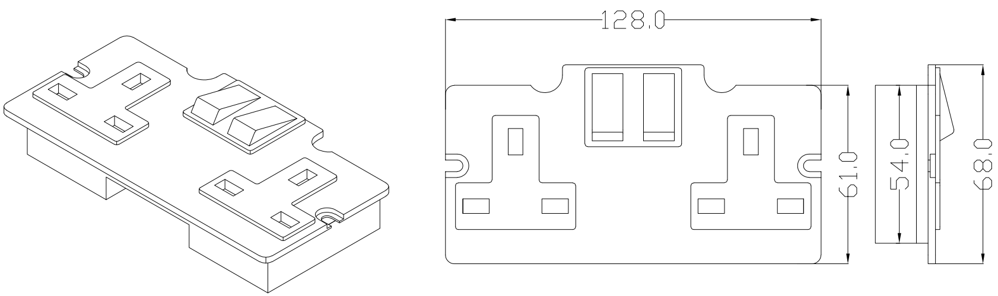
5) 120 Type Funtion Accesoies
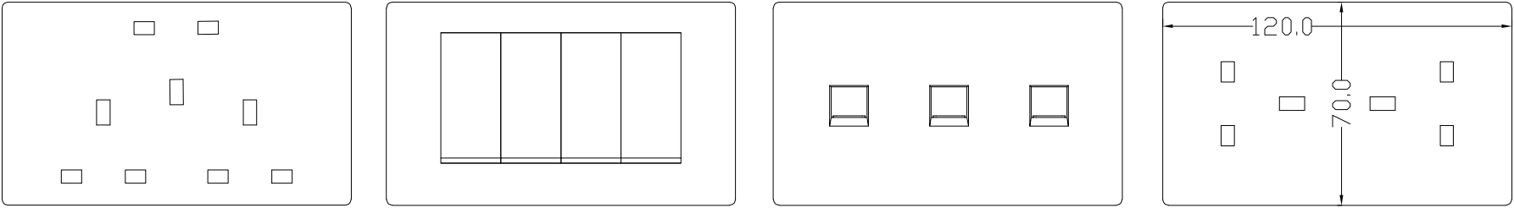
Installation Process:
- Locating the opening: Based on the product design and usage requirements, determine the installation position on the desktop.Reserve installation space.
- Pre-installed base box and wiring: Fix the matching installation base box below the opening on the tabletop. Pass all the power cables, data cables, etc. through the base box and the tabletop opening to prepare for subsequent wiring.
- Pre-installation wiring: Secure the mounting base box. After connecting the power cord correctly to the terminal block of the desktop plug module in accordance with the electrical specifications, insert the desktop plug module into the pre-installed base box.
4. Align the desktop plug function module with the main frame until it is fully inserted and locked in place.
5. Test cleaning: Power on and test all functions. Clean the panel and the surrounding desktop.
1）Screed floor:
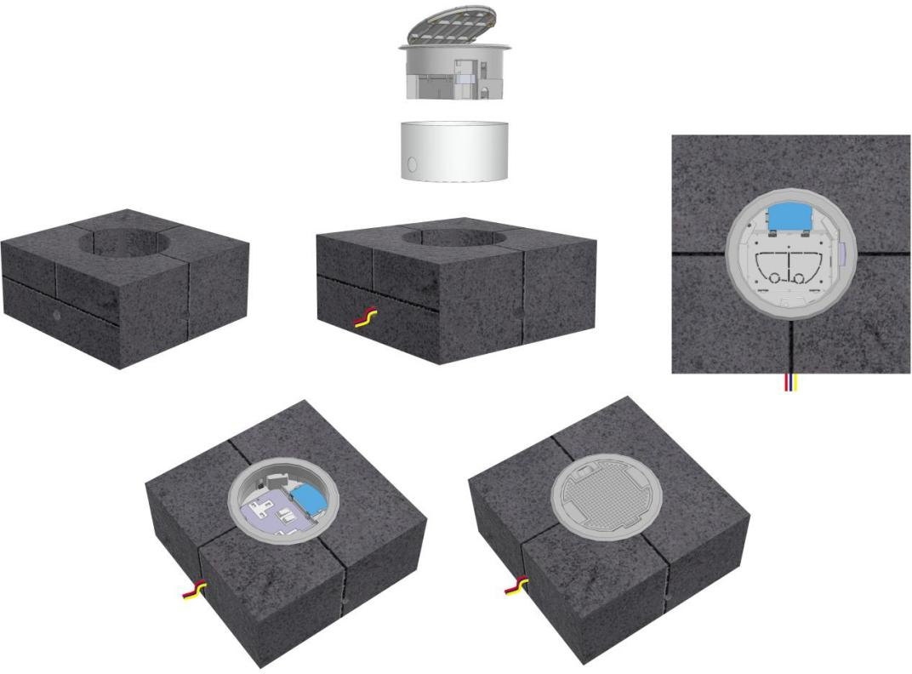
2）Raised floor system:
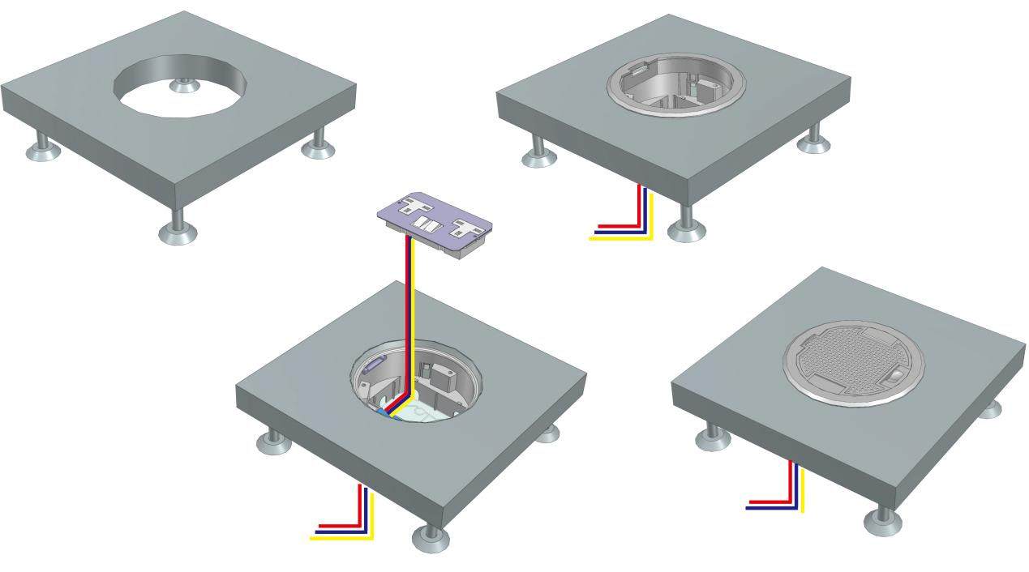
3）Screed floor (Height-adjustable outer frame base):
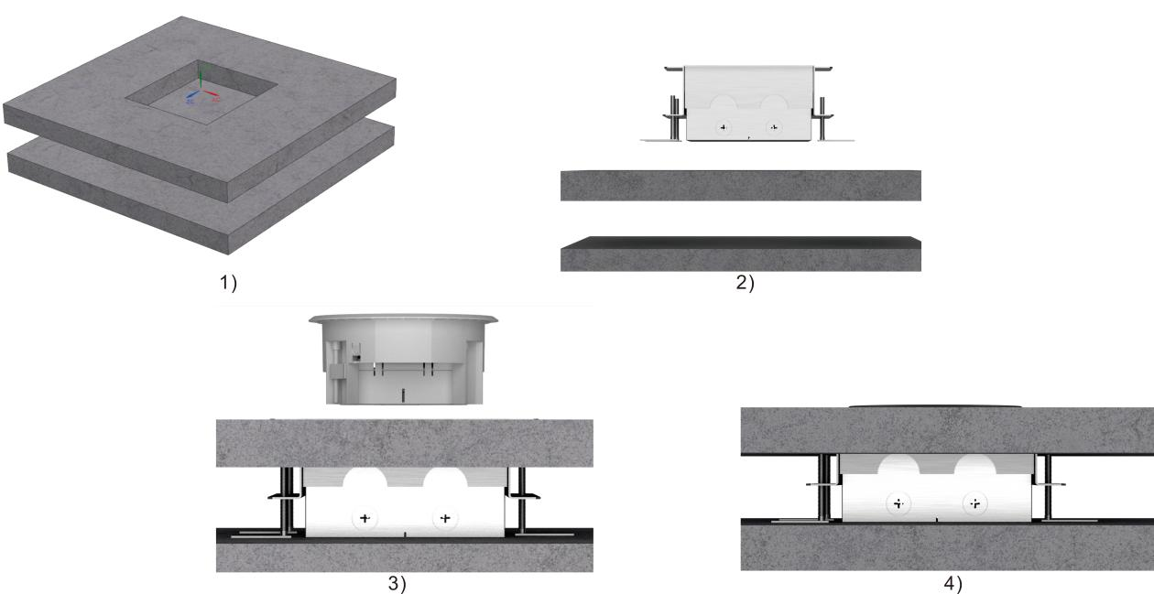
Attentions:
- Prevent from corrosive liquid, gas (strong acid, strong alkali, paint)and humidity.
- All dimension quoted are nominal only. Drawings , images and text are for illustrative purposes only and product details and dimension are subject to change without notice.

Safety Warning:
IMPORTANT: Read all instructions before installing Floor box .
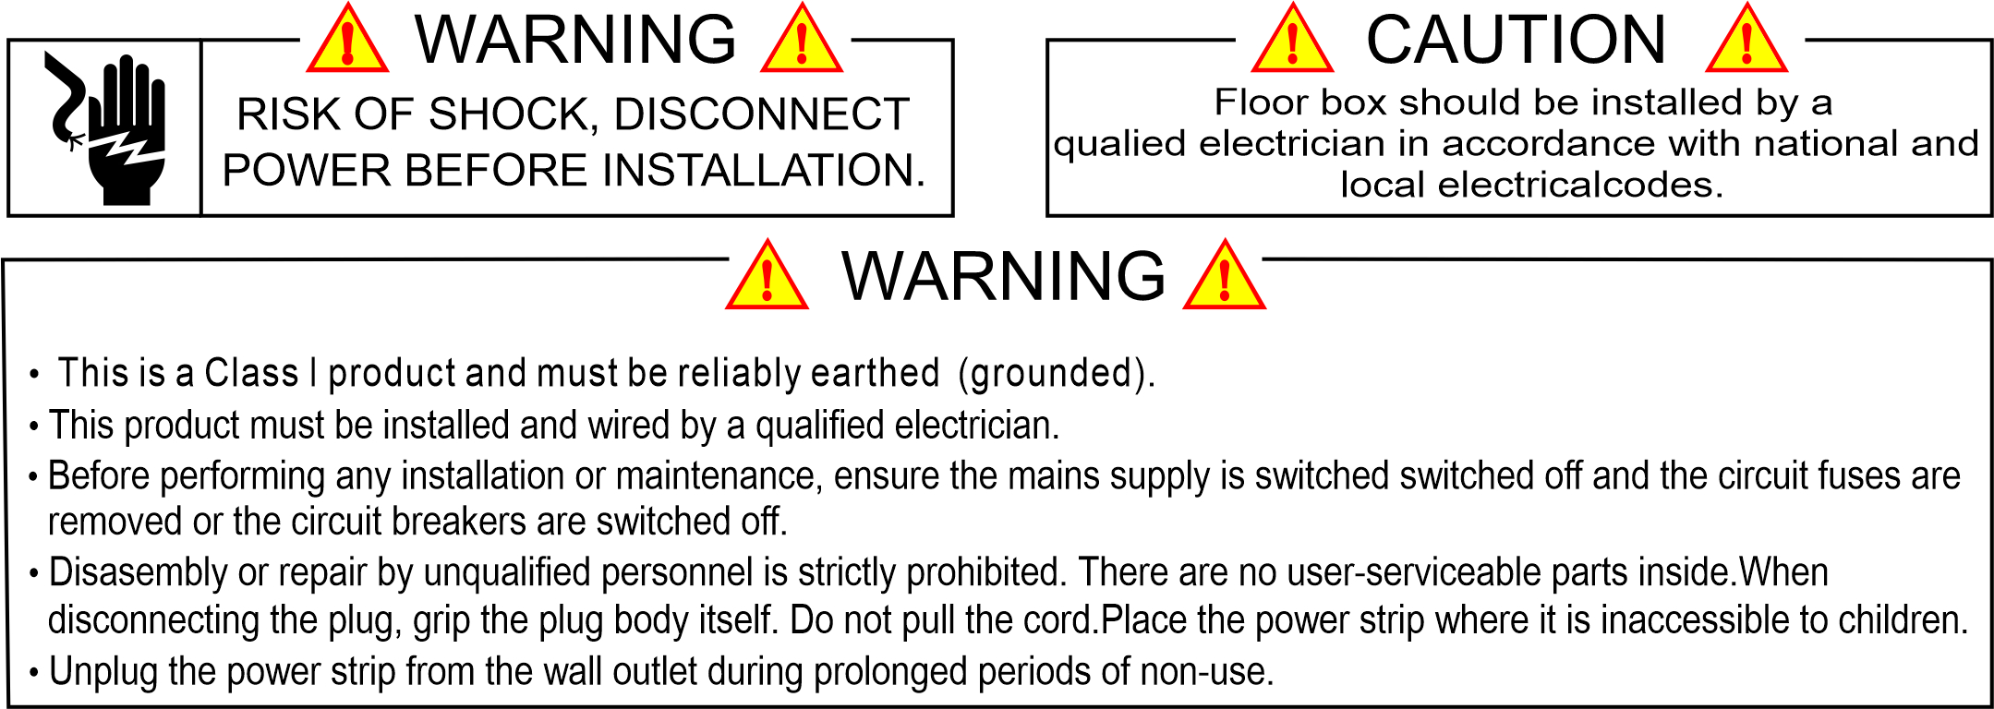
Thank you for choosing the products of Safewire!

